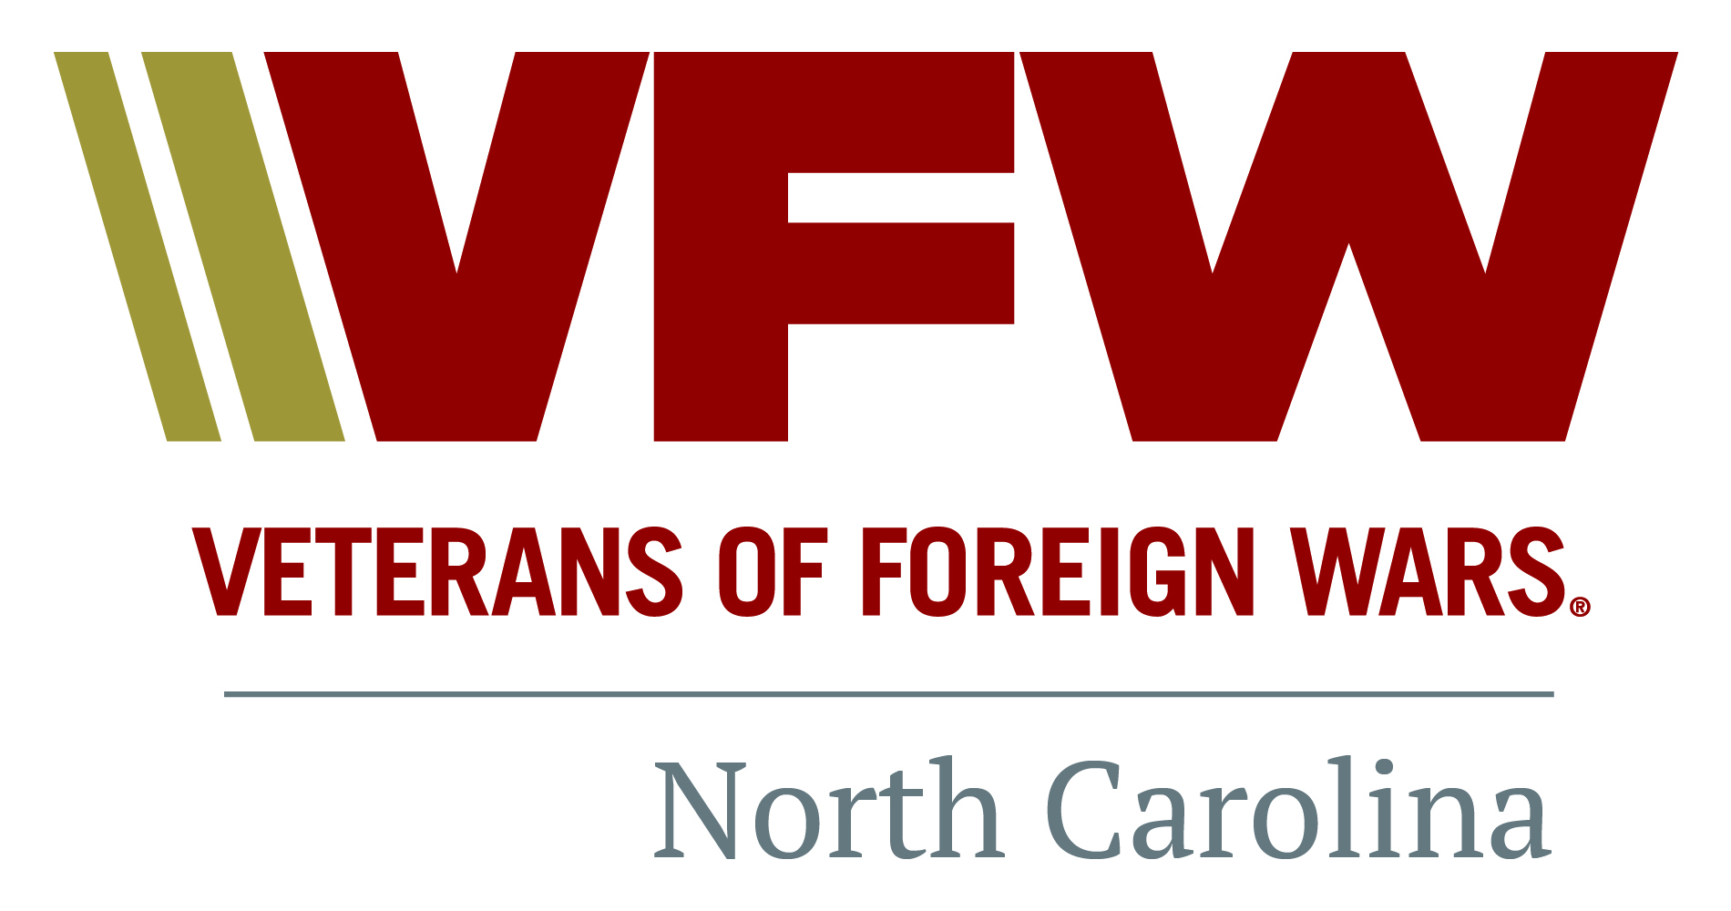
Veterans of Foreign Wars
Post – , North Carolina
New Member Information Packet

Welcome from the Post Commander

Greetings Comrade!
On behalf of the Veterans of Foreign Wars Post _____, allow me to welcome you to our organization! Whether you are new to the VFW or are simply transferring from another Post, I’d like to personally thank you for your service to our country and your decision to be a part of America’s oldest organization of combat veterans.
Within this packet you will find a large amount of information and I encourage you to review at your convenience to learn about our organization. We are made up of combat veterans who volunteer our time, labor and expertise to bring a wide range of abilities to benefit the organization. However, it is every member’s responsibility to bring honor to the organization and continue to introduce new members to the VFW and our commitment to the community.
If you have grandparents, spouse, siblings, children and grandchildren then we would love them to consider joining our Auxiliary. You may contact our President at any time for the necessary application and additional information regarding their organization.
Finally, our Post meetings take place every ____________, and as a member you are encouraged to take part in this most critical activity of Post business. Without members like you being actively involved, our Post will never succeed!
If you have any questions concerning our organization, please feel free to contact me at any time, day or night. We have a wide range of programs to participate in and we look forward to you and your family’s involvement in our organization!
Most Sincerely,

Post Commander
VFW _______
Mobile: (000) 000-0000
Email:

Table of Contents

- VFW Officer Contact List
- Officers’ Roles and Responsibilities
- VFW Ritual and Meeting Protocol
- History of the Cross of Malta
- History of the VFW
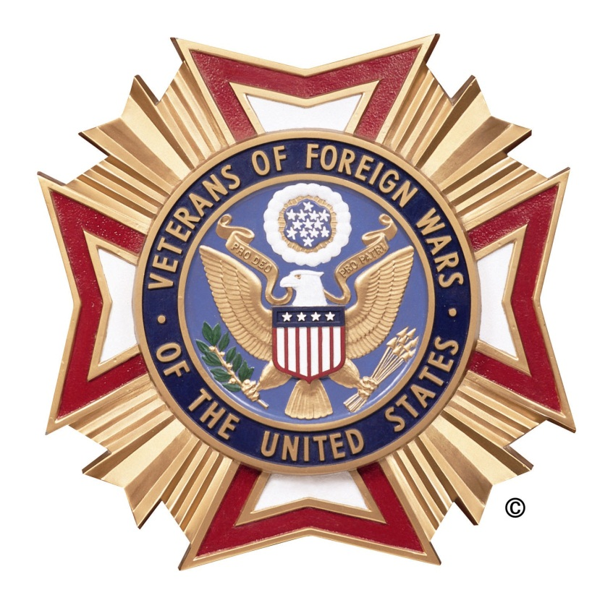
- Websites and Resource List

VFW Post ________ Officer Contact List

Post Commander
Name
Mobile: 000-000-0000
Email:

Post Senior Vice Commander
Name
Mobile: 000-000-0000
Email: John.Doe@email.com

Post Junior Vice Commander
Name
Mobile: 000-000-0000
Email: John.Doe@email.com

Post Quartermaster
Name
Mobile: (000-000-0000
Email:

Post Adjutant
Name
Mobile: 000-000-0000
Email:

Post Chaplain
Name
Mobile: 000-000-0000
Email: John.Doe@email.com

Post Service Officer

Name
Mobile: 000-000-0000
Email: John.Doe@email.com

VFW Officer Roles and Responsibilities

NOTE: All officers’ roles and responsibilities have been paraphrased for the purpose of brevity within this document. Formal duties and obligations for Post officers can be found within Sec. 218 – Officers: Duties and Obligations in the VFW Manual of Procedure.
Commander:
- Presides at all meetings of the Post, conducting such meetings in accordance with the By-Laws, Manual of Procedure and other Parliamentary rules;
- Appoint officers, committee chairmen and committees not otherwise provided for. He may remove such appointed officers, committee chairmen and committees at his pleasure. He shall, by virtue of his office, be a member of all committees;
- Approve all disbursements of funds properly authorized by the Post
- Assure that all reports are correctly prepared and promptly forwarded, that all the business of the Post is handled with dispatch and that all necessary licenses and permits are obtained for proper operation;
- Assure that Post Trustees have examined the books and records of the Post and prepared the Post Trustee Quarterly Report of Audit no later than the end of the month following the last day of each quarterly period, forwarding a copy to the Department Quartermaster;
- Assure that he or his representative attends all properly called District Conventions or meetings.
Senior Vice Commander:
- Shall assist the Commander in preserving order, preside in the absence of the Commander, provide such advice or assistance as may be required and perform such other duties as are incident to such office or may from time to time be required by the laws and usages of the organization or lawful orders from proper authority.
- Within the Post, the Senior Vice Commander also serves as the Membership Committee Chairman.

Junior Vice Commander:
- Shall assist the Commander in preserving order, preside in the absence of the Commander and Senior Vice Commander, provide such advice or assistance as may be required and perform such other duties as are incident to such office or may be from time to time be required of him by the laws and usages of the organization or lawful orders from proper authority.
- Within the Post, the Junior Vice Commander also serves as the Youth Activities Committee Chairman.
Quartermaster:
- Collect all monies due the Post, giving receipt therefore, and have charge of the funds, securities and other property of the Post, all of which shall be placed in his care. He shall be the accountable officer of the Post and the Treasurer of all committees handling funds.
- Disburse funds as properly authorized by the Post using accepted banking practices. All disbursements of Post funds shall bear the signature of the Quartermaster or other person(s) authorized by the Quartermaster.
- Provide the Post Trustees with all record, files and statements required or necessary for the preparation of the Post Trustees Quarterly Report of Audit;
- Report on transactions concerning receipts and expenditures, for any given period, at a regular or special meeting of the Post.
Adjutant:
- The official corresponding officer for the Post and shall attest to all official communications and reports with his signature;
- Under the direction of the Commander, prepare all reports and returns required of him;
- Maintain a copy of the original application of every member admitted to the Post, minutes of each Post meeting after correction and approval, all current orders or circulars issued by the Commander-in-Chief, National Council of Administration, Department Commander, District Commander and Post Commander;
- Maintain a current copy of the By-Laws, Manual of Procedure and Ritual of the Post, Department, and District.
Chaplain:
- Shall perform such duties as are incident to the office or as may from time to time be required of him by the laws and usages of this organization or lawful orders from proper authority.

VFW Ritual and Meeting Protocol

We do not want our Post members, new or old, to feel uncomfortable or embarrassed at any meeting or luncheon. The following are some of the more important General Rules to try to remember.
1. When addressing the Commander, all officers stand at attention and salute in a military manner. The Commander will return similar salutes. All officers stand and exchange salutes when addressing each other.
2. One rap of the gavel calls attention or seats the body when standing.
Two raps of the gavel means “stand up” and calls everyone to standing at attention.
3. While the Post is in session, no member shall pass between the altar and the commander’s station, except as prescribed by the Ritual. This space represents the sacred ground where our comrades who have answered the final roll call are at rest.
4. All VFW military formations and procedures shall conform with current United States Army Infantry Drill Regulations.
5. The Officer of the Day shall act as the master of ceremonies.
6. All members will stand during rendition of prayers and will follow the action of the Chaplain or presiding officer relative to removal of caps during prayers; if uncovering, the hat shall be placed on the extended closed fingers of the right hand in such a way that the Cross of Malta is exposed and held over the heart.
7. Official caps will not be worn during luncheons, banquets or other meals.
8. Official caps will be the only head covering allowed to be worn at regular meetings of the Veteran of Foreign Wars of the United States.
9. On approaching the door of a Post meeting while in session, a member will give two knocks to attract the attention of the guard who will challenge, “Who knocks here?” Member will answer with his name and the number of the Post he is from. The guard will then report to the Senior Vice Commander, who will order him to admit the member, if proper. The guard will then open the door and the member will show his membership card. Upon being admitted to the Post room, the member will advance to the altar and salute the Commander. Should the Commander be busy, the member will face about and salute the Senior Vice Commander, after which he will be seated.
10. When wishing to retire while the Post is in session, members will advance to the altar and use the same sign as when entering, to the Commander or Senior Vice Commander, and when answered, member may retire.
11. In meetings of the VFW, members holding office shall be addressed as “Comrade” followed by the title of the office they hold. All other members shall be addressed as “Comrade.”
12. Any procedural matter governing meetings not provided for by the VFW Rules of Order shall be governed by Demeter’s Manual of Parliamentary Law and Procedure.
13. The presence and/or consumption of alcoholic beverages in VFW meeting rooms and nearby hallway during VFW meetings is unacceptable and is prohibited.
14. No member shall in debate impeach the motives of a fellow member or treat him with disrespect. Members shall avoid personalities and unbecoming speech.
Through the generations we give life to our impressive VFW Ritual, for it solemnly binds young and old into the brotherhood of men who have fought for America on land, on sea, and in the air.

History of the Cross of Malta

The Veterans of Foreign Wars of the United States adopted for its symbol the Cross of Malta, which has a heritage of honor, duty, sacrifice and courage that dates back to the 11th century. The Cross has its origin in the Knights of St. John, a strict order of crusaders originally founded to maintain a hospital for pilgrims journeying to the Holy Land. From this order evolved two divisions, the Knights Templar, famed for their ability to fight, and the Knights Hospitaler, humanitarians who provided for the sick and distressed.
The Knights established branches throughout Europe and moved their headquarters to Cyprus. From Cyprus the headquarters was eventually moved to Rhodes in the 14th century and was transferred from there to the island of Malta in the 16th century. There they became known as the Knights of Malta.
The insignia of the Knights of Malta is basically the same as the one used today by the Veterans of Foreign Wars. It is an 8-pointed cross formed by four arrowheads meeting at the points. Each represents one of the Beatitudes taken from Jesus’ Sermon on the Mount. The arrowheads indicated the knights were willing to fight for the principles of justice and truth although their order was basically a peaceful one.
This outlook is similar to that of the VFW, devoted to peace but comprised of men who have fought and are willing to fight again, for those principles which embody the individual liberties and dignities of men. The fundamental objectives of the organization are set forth in a charter granted it by the Congress of the United States in 1936.
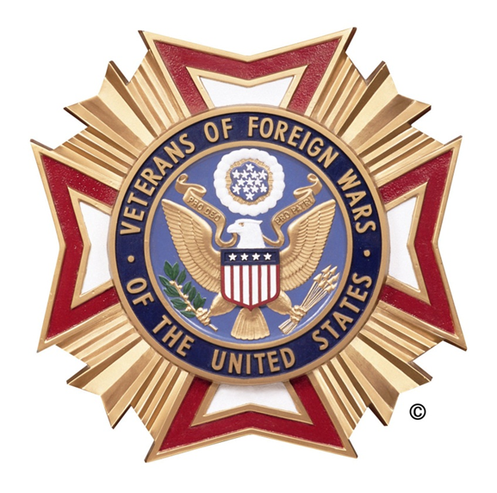

History of the VFW

The VFW traces its roots back to 1899 when veterans of the Spanish-American War (1898) and the Philippine Insurrection (1899-1902) founded local organizations to secure rights and benefits for their service: Many arrived home wounded or sick. There was no medical care or veterans' pension for them, and they were left to care for themselves.
In their misery, some of these veterans banded together and formed organizations with what would become known as the Veterans of Foreign Wars of the United States. After chapters were formed in Ohio, Colorado and Pennsylvania, the movement quickly gained momentum. By 1915, membership grew to 5,000; by 1936, membership was almost 200,000.
Since then, the VFW's voice had been instrumental in establishing the Veterans Administration, creating a GI bill for the 20th century, the development of the national cemetery system and the fight for compensation for Vietnam vets exposed to Agent Orange and for veterans diagnosed with Gulf War Syndrome. In 2008, VFW won a long-fought victory with the passing of a GI Bill for the 21st Century, giving expanded educational benefits to America's active-duty service members, and members of the Guard and Reserves, fighting in Iraq and Afghanistan.
The VFW also has fought for improving VA medical centers services for women veterans.
Besides helping fund the creation of the Vietnam, Korean War, World War II and Women in Military Service memorials, the VFW in 2005 became the first veterans' organization to contribute to building the new Disabled Veterans for Life Memorial, which opened in November 2010.
Annually, the 2.1 million members of the VFW and its Auxiliary contribute more than 11 million hours of volunteerism in the community, including participation in Make A Difference Day and National Volunteer Week.
From providing over $3 million in college scholarships and savings bonds to students every year, to encouraging elevation of the Department of Veterans Affairs to the president's cabinet, the VFW is there.

Websites and Resource List

- Veterans of Foreign Wars Network Websites
Veterans of Foreign Wars National Website – http://www.vfw.org
North Carolina VFW Department Website – http://www.vfwnc.com
VFW Merchandise Sales – http://www.vfwstore.org
- Veterans Assistance Websites
U.S. Department of Veterans Affairs – http://www.va.gov
VA Mental Health Home Page - http://www.mentalhealth.va.gov
eBenefits Website – https://www.ebenefits.va.gov
MyHealtheVet Website - https://www.myhealth.va.gov

- Phone Numbers and Contacts
VFW Post ####
PO Box ###
City, State #####

(###) ###-####

Local VA Outpatient Clinic
#### Main Street
City, State #####

(###) ###-####

Veterans Crisis Line (Anonymous) – (800) 273-8255

